**Chapter-1**

**Study of Existing system and system requirements.**

**Hardware & Software Requirement:**

**Hardware Interfaces**

* Minimum Hardware requirement
* Processor: P4 3.0 GHz
* RAM:1 GB or Higher
* Monitor
* Mouse
* Hard disk: 80 GB

**Software Interfaces**

* Minimum Software requirement
* Java (JSP and Servlet)
* Apache Tomcat Server

All these types of software automatic configure inside operating system after installation it having Java, MYSQL, Apache and operating system base configuration file, it doesn’t need to configure manually.

Introduction

As we know, today in this digital world everything is moving online whether it is related to learning or booking. So, The Online Bus Booking system is developed to automate the manual process of booking buses by using the application. You can book ticket according to your choice.

This application is developed to support all roles i.e. any customer or user can avail the benefit of this application. Here, there are two main roles in this application one is the Admin who is the administrator of the application and who can add Buses Information, edit bus information, and delete it and so on. Also, Admin can view the booking history. The customer who is another user of this application can book the ticket according to their requirement.

This application will not only help the customers but also to the Admin who wish to start an online booking system business.

Objective

The main objective of this project is to build a robust application through which it is most convenient for any customer to book a ticket at any time from any place.

It is developed to manage the information of Buses, customer, ticket. The Admin who is the administrator of this application has an access of adding the information. The customers will the end user who is going to book a ticket online.

Here, this application keeps a track of all the booking done by customers thus reduces the manual work of maintaining record with an automated system.

Methodologies

There are two main role of this application. One is the Admin who will add the Buses and another is the customer who will book ticket.

**1) Admin**

* Admin can VIEW/ADD/UPDATE/DELETE Buses.
* Admin can VIEW Booking History.
* Admin can VIEW the Buses report.

**2) Customer/End user**

* Customer can VIEW the available bus.
* Customers can Book Ticket.
* Customers can VIEW Booking History.

***Note: The Login, registration module is common to all the users.***

**Chapter-2**

**System Analysis**

**2.1 E R DIAGRAM**

**Data Flow Diagram (DFD)**

**Level 0:**

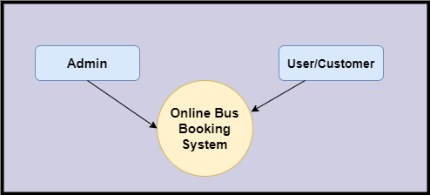

**Level 1**

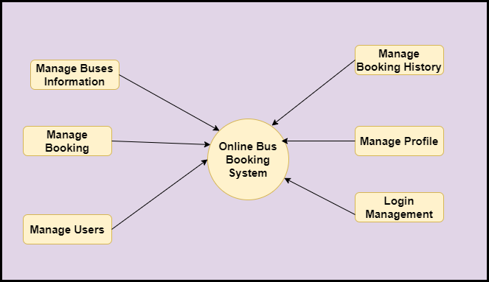

**Level 2-DFD Admin**

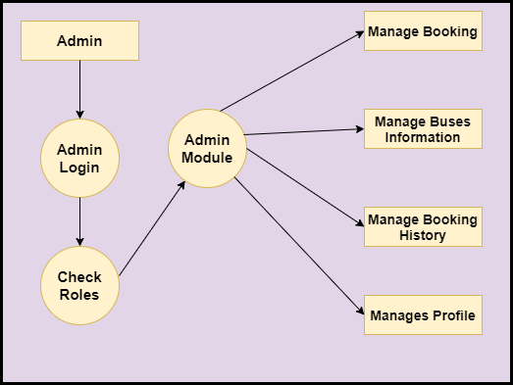

**Level 2-DFD Customer**

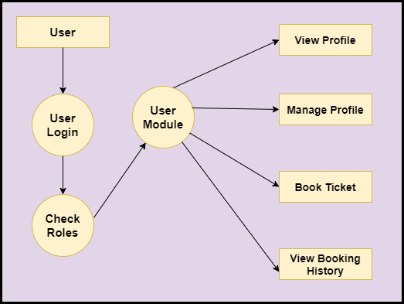

**Feasibility:**

This project will be developed on computer, so first check whether the technology is technically available or not. Now a day’s computer interaction with any job becomes common for any kind of job or work.

And because of increasing usage of Computer, Computer is also available with a variety of hardware. Vendors can fulfill any type of hardware requirement. The whole project is developed by some special tools or by using languages and databases, which are also available in a variety.

Preliminary investigation of a system examines the feasibility of a system that is useful to an organization. It is the first phase of system development.

The main objective of this phase is to identify the current deficiencies in the user’s environment and to determine which existing problem are going to be solve in proposed system and also which new function needs to be added in proposed system.

An important outcome of such preliminary investigation is to determine whether the system that will meet all needed requirements.

Thus, three tests are carried out on the system namely operation, technical and economical.

Any project is beneficial if and only satisfies the organization requirement. For any new system setup, it only meets to be communicated and work the other supporting system.

The new system meets all existing operations since it provides right information at a right time to the right user. A Leigh man can easily operate with the system.

Technical Feasibility examines whether the technology needed is available and if it is available then it feasible to carry out all project activities.

The technical needs of a system include:

* The facility to produce outputs in a given time.
* Ability to process large number of transaction at a particular speed.
* Giving response to users under certain conditions.

The technology needed for our system is mainly:

* Latest version of browsers.
* Any operating system.

These technologies are available which helps to carry out the system efficiently.

Economical feasibility of a system examines whether the finance is available for implementing the new system and whether the money spent is recoverable the satisfaction.

The cost involves is in designing and developing a good investment for the organization.

Thus, hardware requirements used for proposed system are very standard. Moreover, by making use of proposed system to carry out the work speedily will increase and also saves the valuable time of an organization.

In the proposed system the finance is highly required for the installation of the software’s which can also be recovered by implementing a better system.



**Chapter-3**

**Design**

**System Flow Chart:**

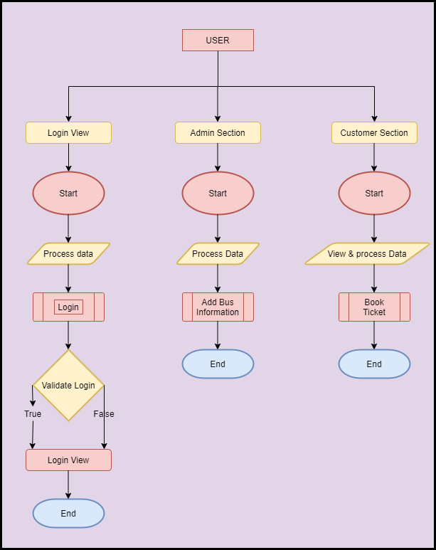

**ER Diagram**

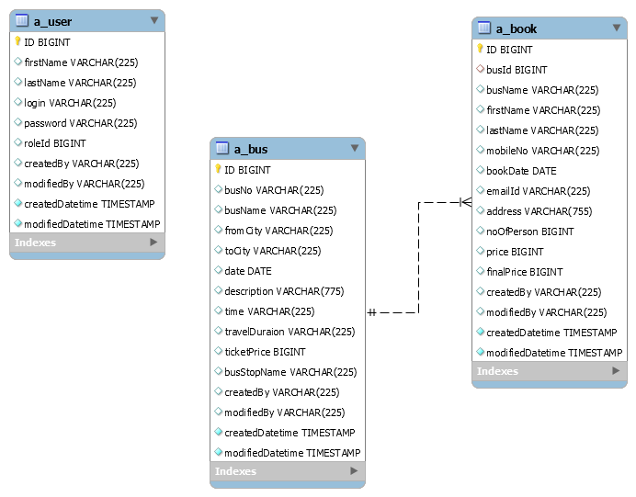

**Data dictionary**

**Data validation:**

Procedures are designed to detect errors in data at a lower level of detail. Data validations have been integrated in the system in almost every area where there is a possibility for the user to commit errors. The system will not recognize invalid data.

Whenever an invalid data is keyed in, the system immediately prompts the user and the user has to again key in the data and the system will accept the data only if the data is correct. Validations have been integrated where necessary.

The system is designed to be a user friendly one. In other words the system has been designed to communicate effectively with the user. The system has been designed with pop up menus.

**Different Type Of validation:**

* Data type validation;
* Range and constraint validation;
* Code and Cross-reference validation; and

Structured validation

**Coding**

**Implementation and Testing:**

**Black-Box Testing**:

Black Box Testing, also known as Behavioural Testing, is a software testing method in which the internal structure/ design/ implementation of the item being tested is not known to the tester. These tests can be functional or non-functional, though usually functional.

This can be following way:

* Input interfacing
* Processing
* Output interfacing



This method is named so because the software program, in the eyes of the tester, is like a black box; inside which one cannot see. This method attempts to find errors in the following categories:

* Incorrect or missing functions
* Interface errors
* Errors in data structures or external database access
* Behaviour or performance errors
* Initialization and termination errors.

**White-Box Testing:**

White Box Testing ,also known as Clear Box Testing, Open Box Testing, Glass Box Testing, Transparent Box Testing, Code-Based Testing or Structural Testing is a software testing method in which the internal structure/ design/ implementation of the item being tested is known to the tester.

The tester chooses inputs to exercise paths through the code and determines the appropriate outputs. Programming know-how and the implementation knowledge is essential.

White box testing is testing beyond the user interface and into the nitty-gritty of a system.

This method is named so because the software program, in the eyes of the tester, is like a white/ transparent box; inside which one clearly sees.

**Limitations and Future Application of the Project**

**Futures Enhancement:**

* In future we can expand this project on the web.
* In future, we can make module where we can give offers to those who uses the application more often.

**Limitation :**

In this, we don’t send notifications to the customer about ticket booking.

**Screen Snapshot**

**Conclusion**

The Online Bus Booking System will allow the customers to place their booking in a most convenient way. Using this application, they can book according to their timing like it can be a day or night.

Not only this, they can view their booking history as well. Here, everybody can book tickets online based on their requirement instead of standing in the queue.

This application is designed in such a way that any future modification can be done most easily.